# VPC Tasks 2

1. Create one VPC, with 1 public subnet and 1 private subnet.

* Go to aws ec2 console --> select the vpc create the vpc
* Then go to the subnet.
* Create one private subnet.
* And one public subnet and one private subnet .
* Here the results are:

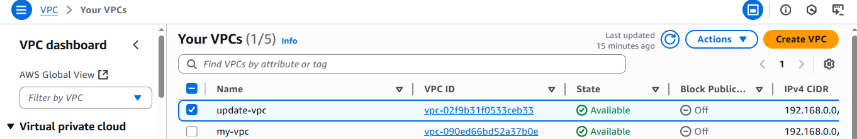

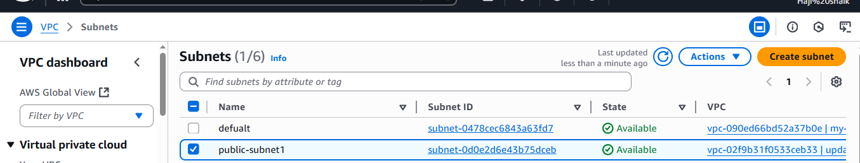



1. Enable VPC peering for cross-region.

* Go to ec2 console.
* Open a search bar and press **VPC.**
* Create 2 vpc with “**Different Region” Ex:** one in eu-stokholm and one is N.Verginia.
* This 2 vpc in **CIDR**  range should be different. One in class **A** range and other one is class **C** range.
* Class A should be **10.0.0.16/24**
* Class C Should be **192.168.0.0./24**
* Then go cross peering option.
* Then select one vpc for request and other one is acceptance.
* **HERE THE RESULTS ARE:**

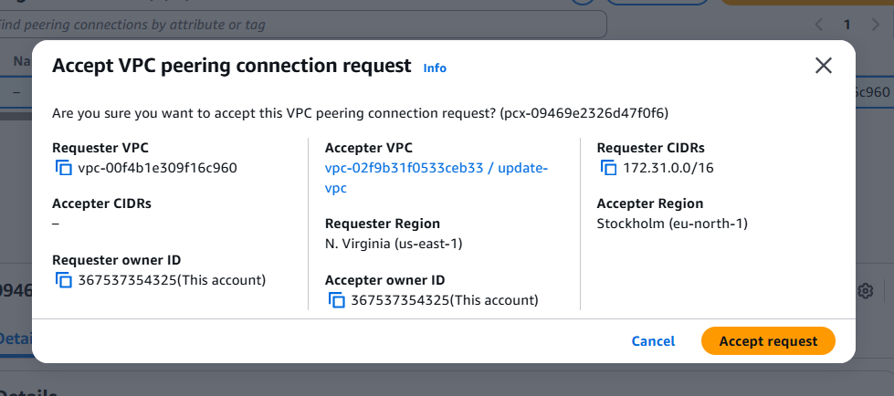

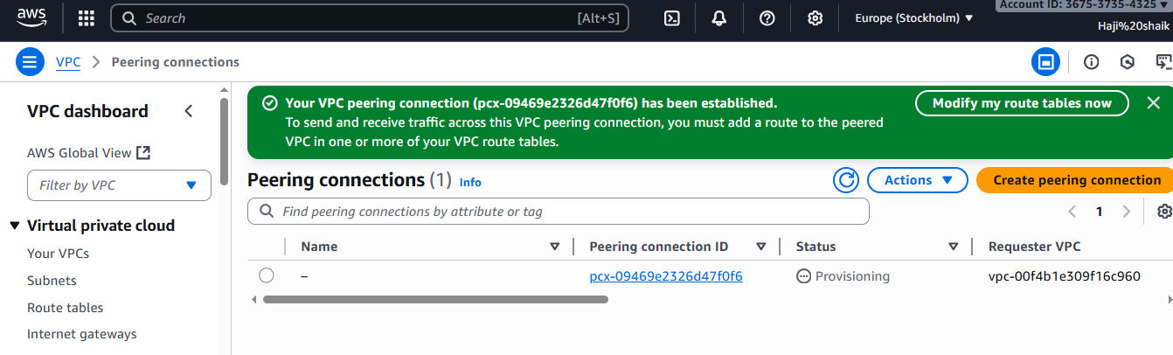

1. Enable VPC peering for cross-account (you can collaborate with your friend to do this task).

* go to the ec2 concole.
* Open search bar and enter in **VPC** then check ur **VPC**  in Which region.
* Then go to **Cross Peering** select your VPC and gave ur region.
* Then enter **friend account id VPC id and Region.**
* before of this  **Choose different account & Different region.**

This is my Page: Where to I send a request..

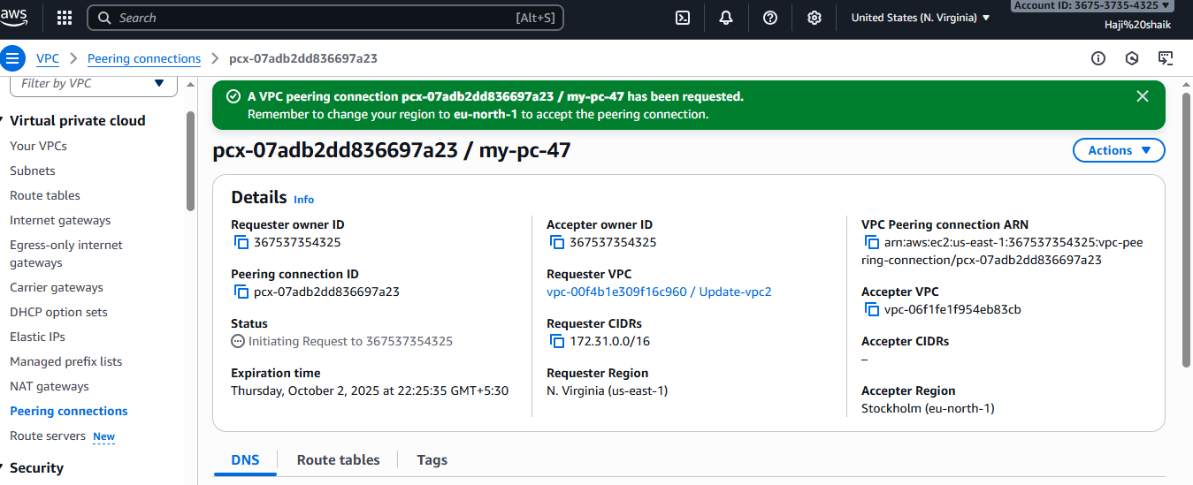

**Here the results Are: Other Region other account**

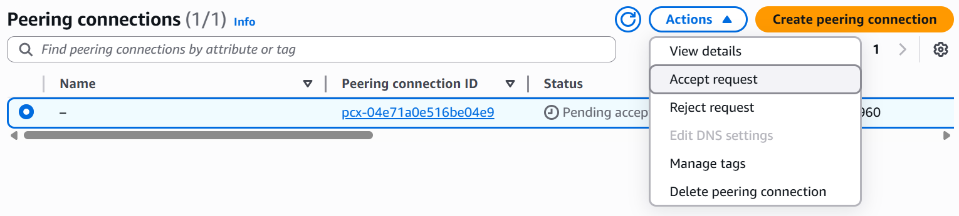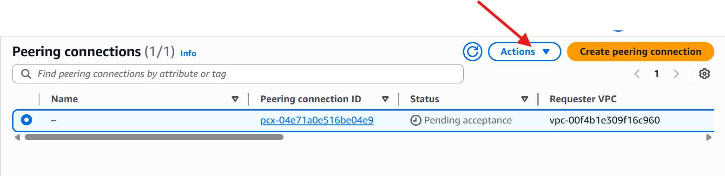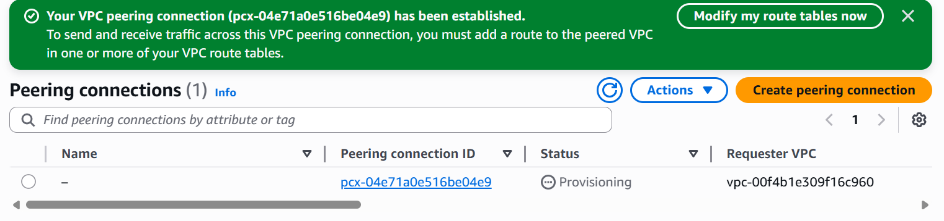

1. Set up a VPC Transit Gateway.

* Go to the ec2 console then open a search bar and enter vpc.
* In that vpc in left pannel there is a **“Transist gateway”**
* Create the transist gateway gave put all defult **Enable DNS**
* Then there is one **Transist attachment** Create attchments the all vpc’s.
* Then go to the vpc route table and update the table.
* And a route on each vpc.

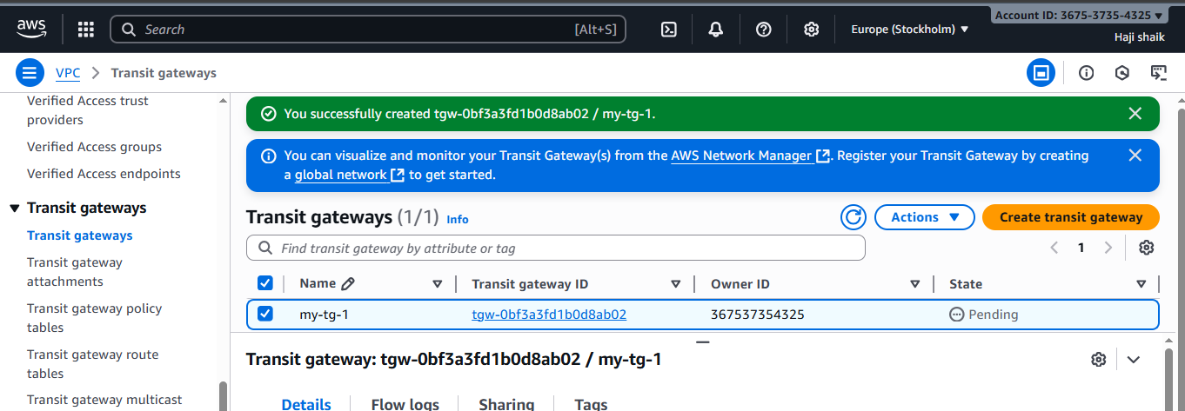

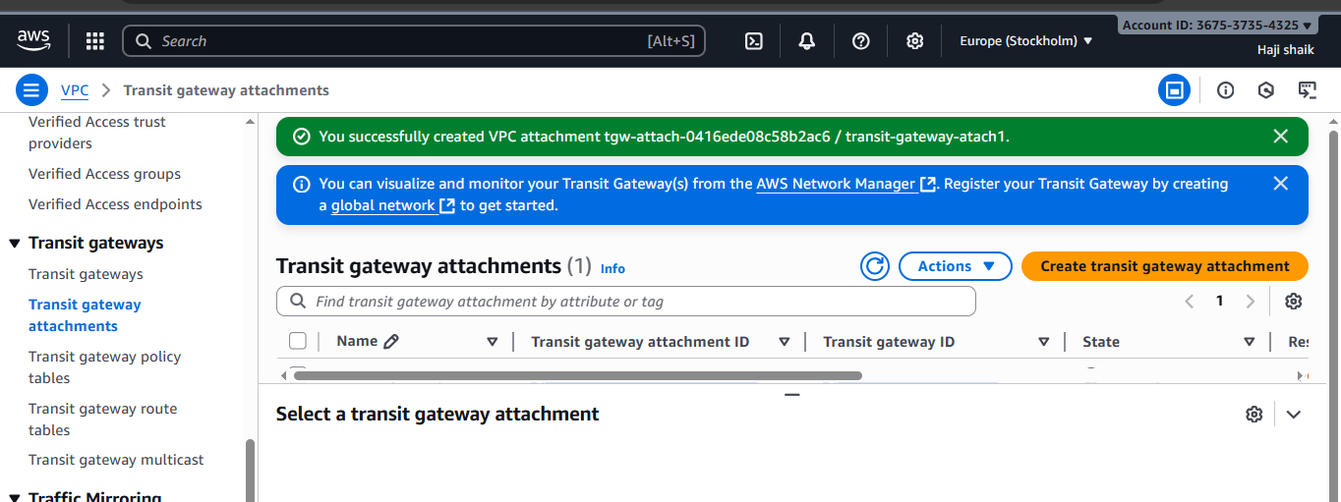

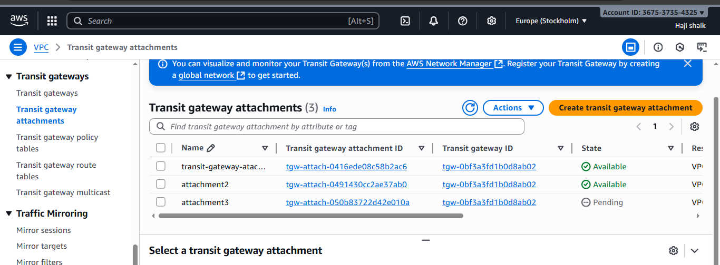

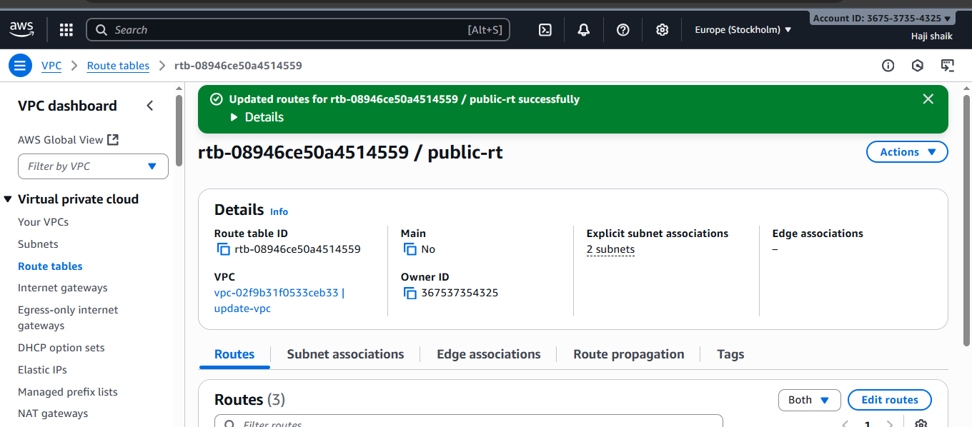

1. Set up a VPC Endpoint.

· Open **AWS Console → VPC → Endpoints → Create Endpoint**.

· **Service category**: AWS Services.

· **Service Name**: type s3 and select your region’s S3 endpoint.

· **VPC**: choose your VPC.

· **Route Tables**: select the route tables of your private subnets.

This will add an entry for S3 in those route tables.

· Leave policy as default (Full Access) or restrict by IAM later.

· Click **Create endpoint**.

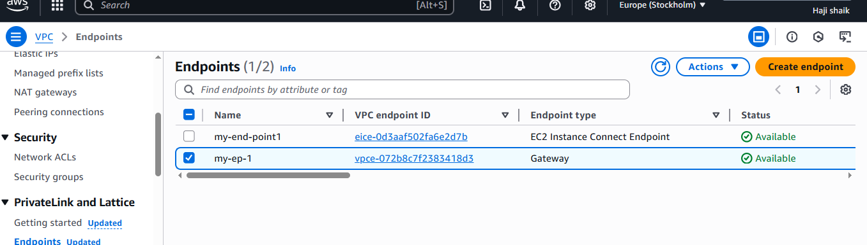

* For check this luanch a private instance.
* Then ssh with private ip.
* Then aws ls.
* Here the results are:

